Why Documentary Wedding Photography Captures the Moments You Will Treasure the Most.

When you look back on your wedding photos twenty years from now, what do you hope you’ll remember?

We all love posed photos that show the dress, the exact bouquet you held, you & the person you love standing perfectly & smiling at the camera. Those picture-perfect moments aren’t ones we ever want to forget, but it’s often the small, unexpected photos that become the moments you treasure most.
Documentary-style photography is an approach that focuses on capturing real moments as they happen candidly, rather than creating or heavily directing them. This doesn’t mean you’ll never be posed. You’ll still receive beautiful portraits & breathtaking family photos with everyone you love. The difference is, throughout the day, I will encourage you to be present while I capture what unfolds naturally instead of constantly directing every moment.
This doesn’t mean your day is completely “hands-off” if you book me to photograph your wedding. I absolutely welcome inspiration photos, meaningful shot requests, & family traditions that might be important to you. If you’ve been dreaming about recreating a certain pose or have a list of must-have moments, I want to know!
My documentary approach simply means that outside of those intentional portraits, I focus on capturing your wedding day as organically as possible. I’ll guide when needed, while also leaving room for genuine laughter, happy tears, quiet glances, and unexpected moments that can’t be planned. The result is a gallery that feels beautifully curated while still telling the honest story of your day.
Your wedding gallery should feel like your wedding, not a Pinterest board I recreated, & not a day that was strictly directed from start to finish. My job is to blend your vision with authentic storytelling so you receive both the photos you’ve dreamed of & the moments you never even realized were happening.
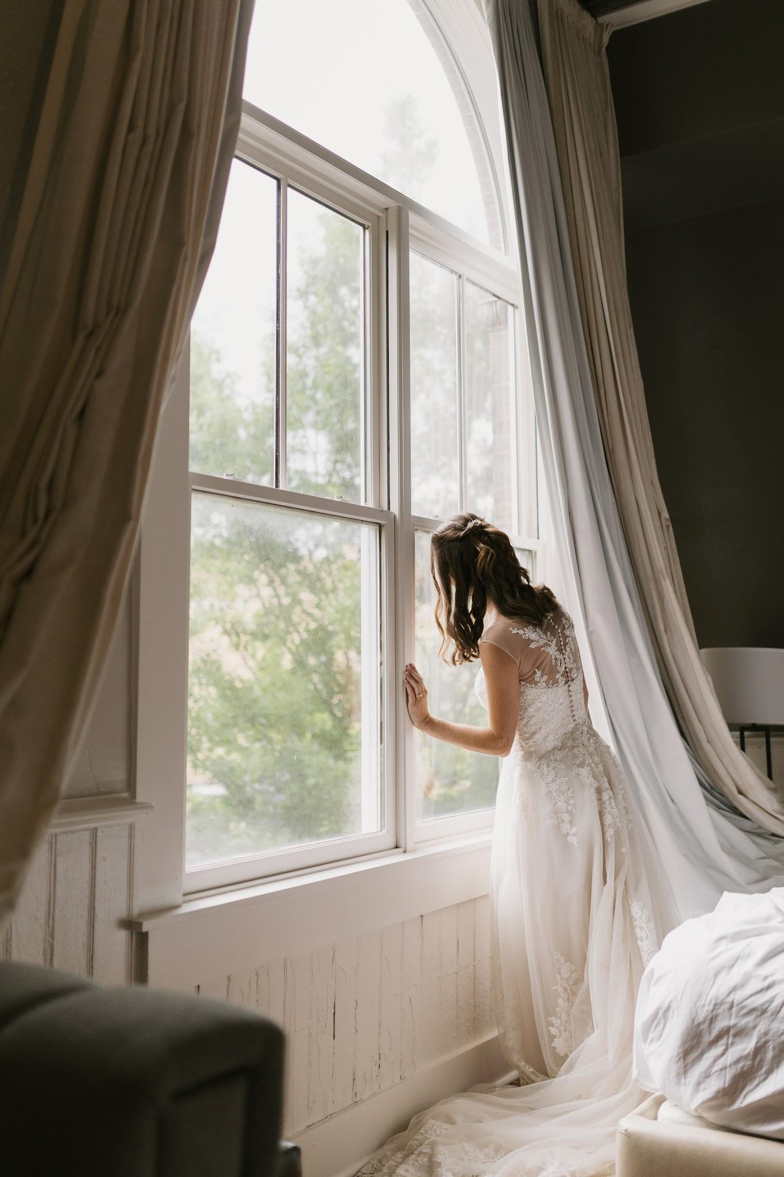
Carson eagerly awaiting the arrival of her groom, JJ, for their first look. He texted her to let her know he was parking, so she peaked out the window to see where he was. Not just a photo, but a memory from their day that made it uniquely theirs.
Hotel Florence - Downtown Florence, SC

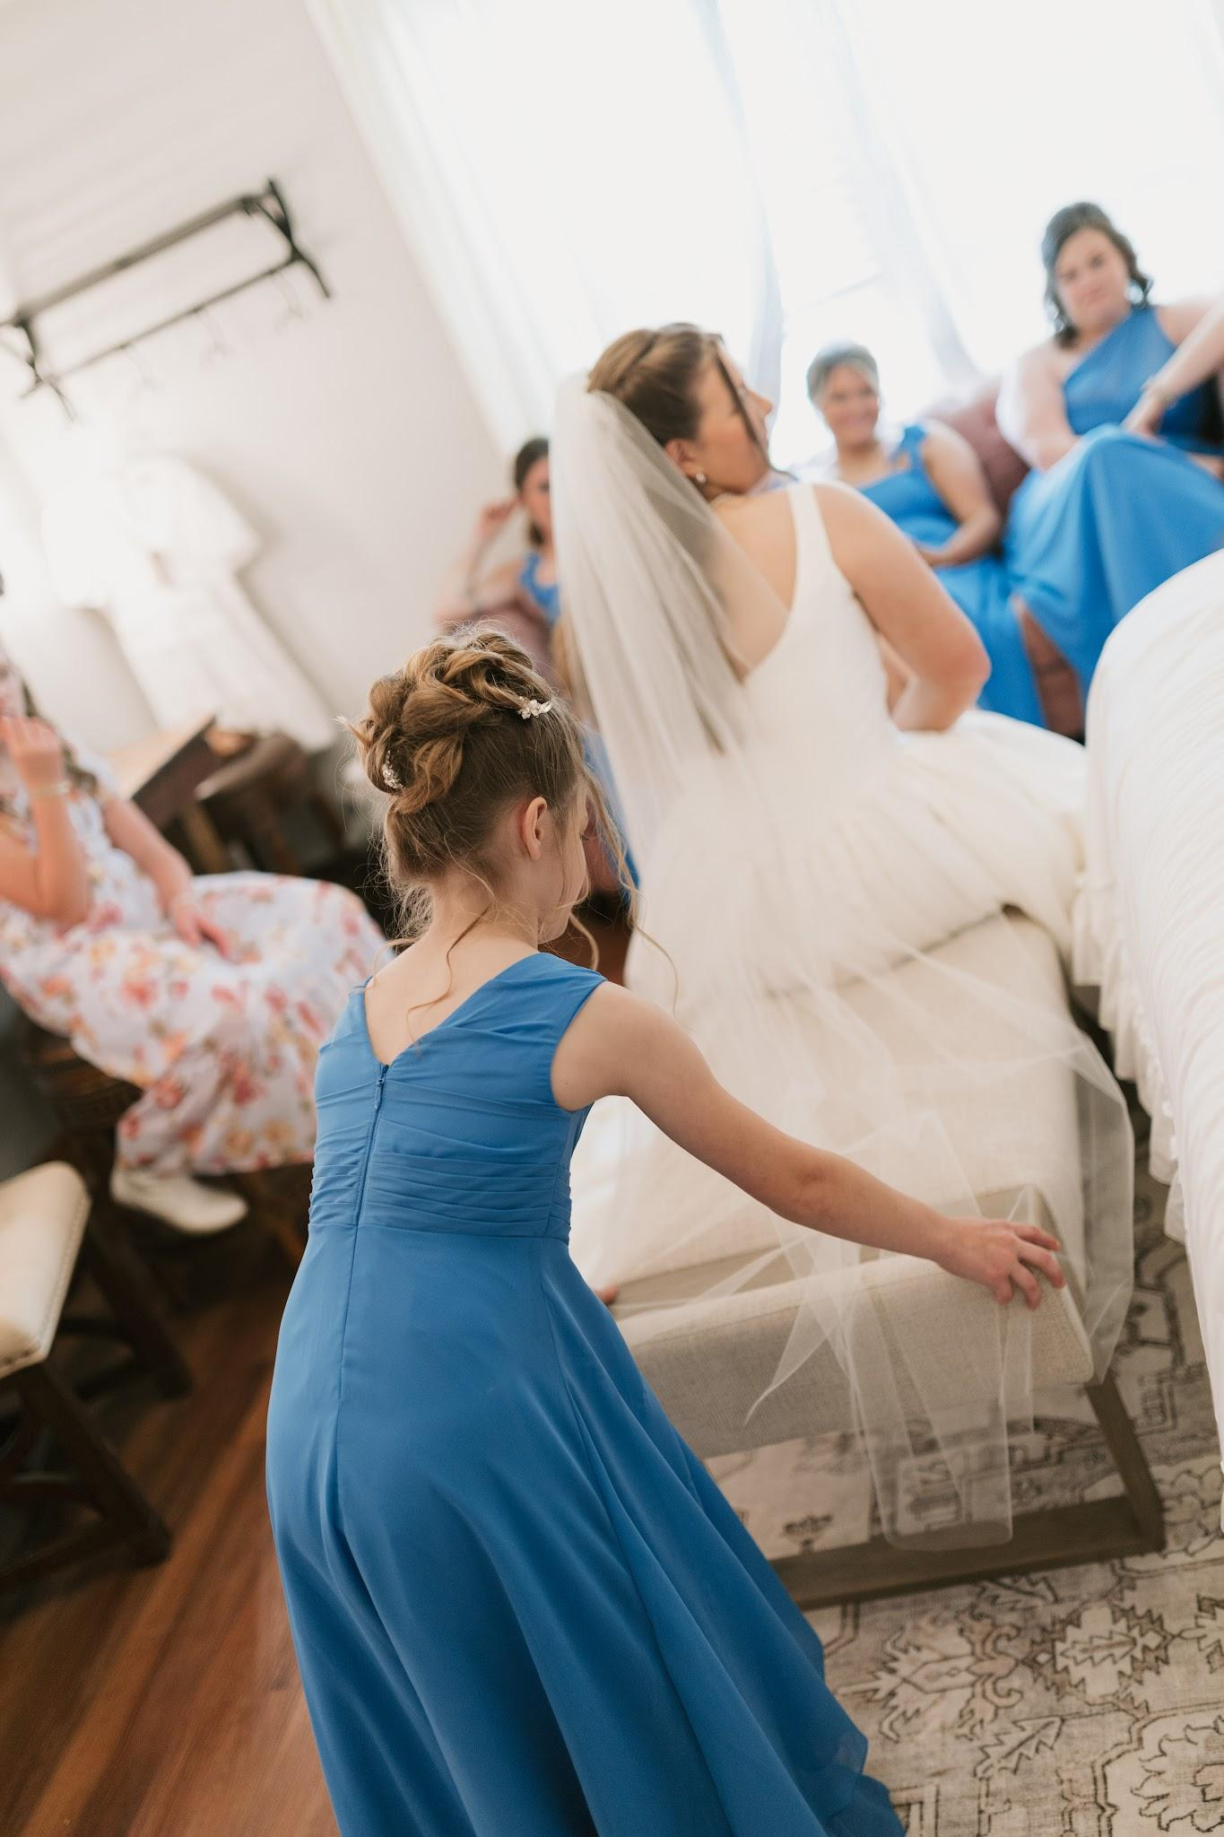
The flower girl unprompted, gently fixes the brides veil moments before she walks down the aisle. I noticed the moment & instantly captured a picture.
The Cabin at Old Spur - Timmonsville, SC

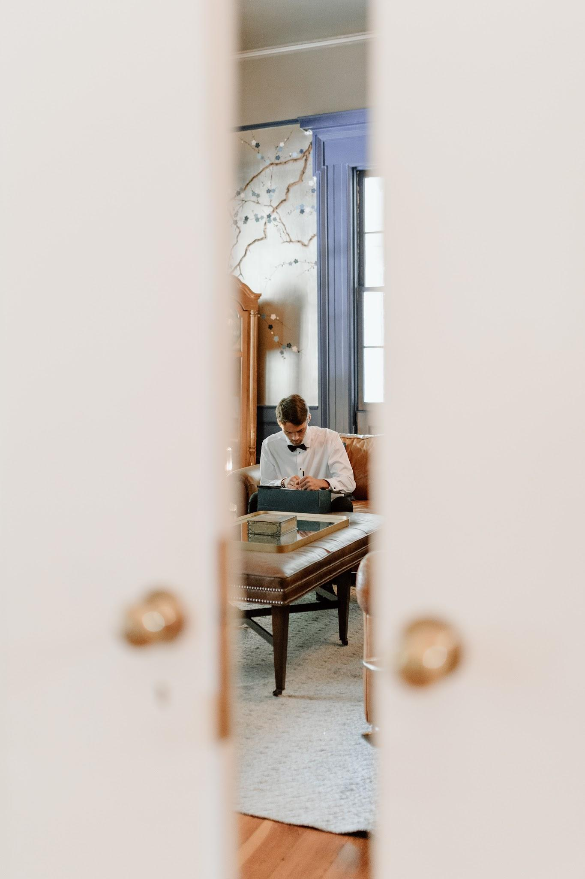
Jet quietly handwriting his vows to the bride as he’s tucked away in the groomsmen suite. I cracked the door & snuck a photo of this intimate moment.
The Terraces - Camden, SC

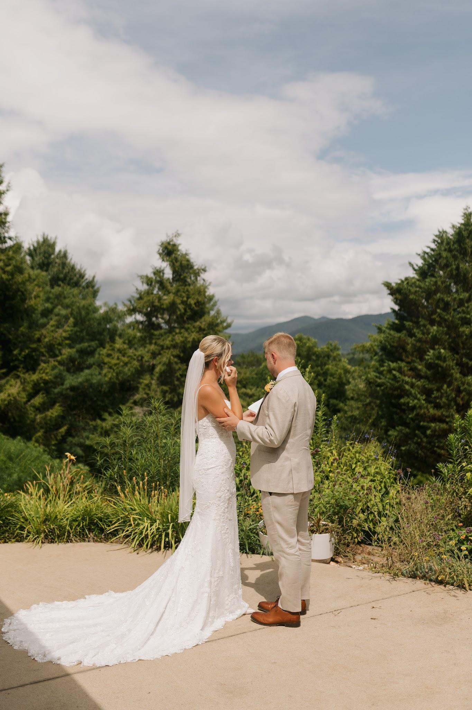
Private vows during Carly & Drew’s first look ended with wiping away tears of joy & a soft, comforting touch from the groom. A moment that started with the two face-to-face, ended in affection & direct touch.
Emerald Ridge - Weaverville, NC

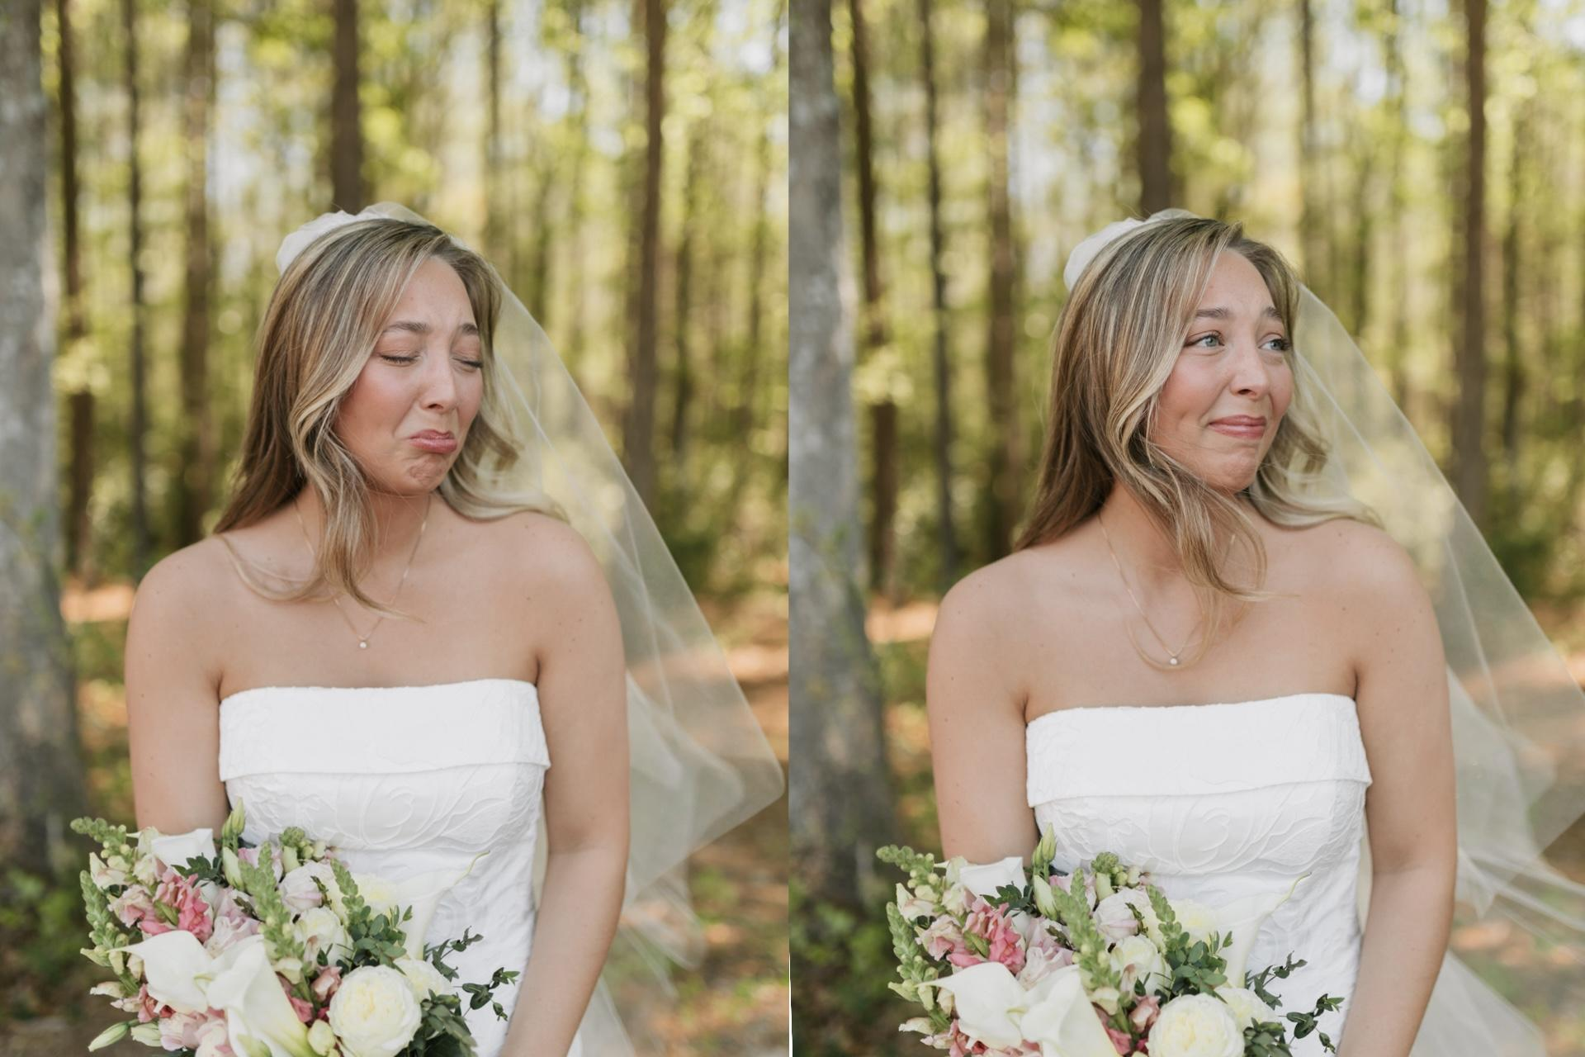
During bridal portraits on her wedding day, Elena expresses genuine emotion as she looks over to her aunt & thanks her for all the work she’s done for her big day.
Griggs Farm - Patrick, SC

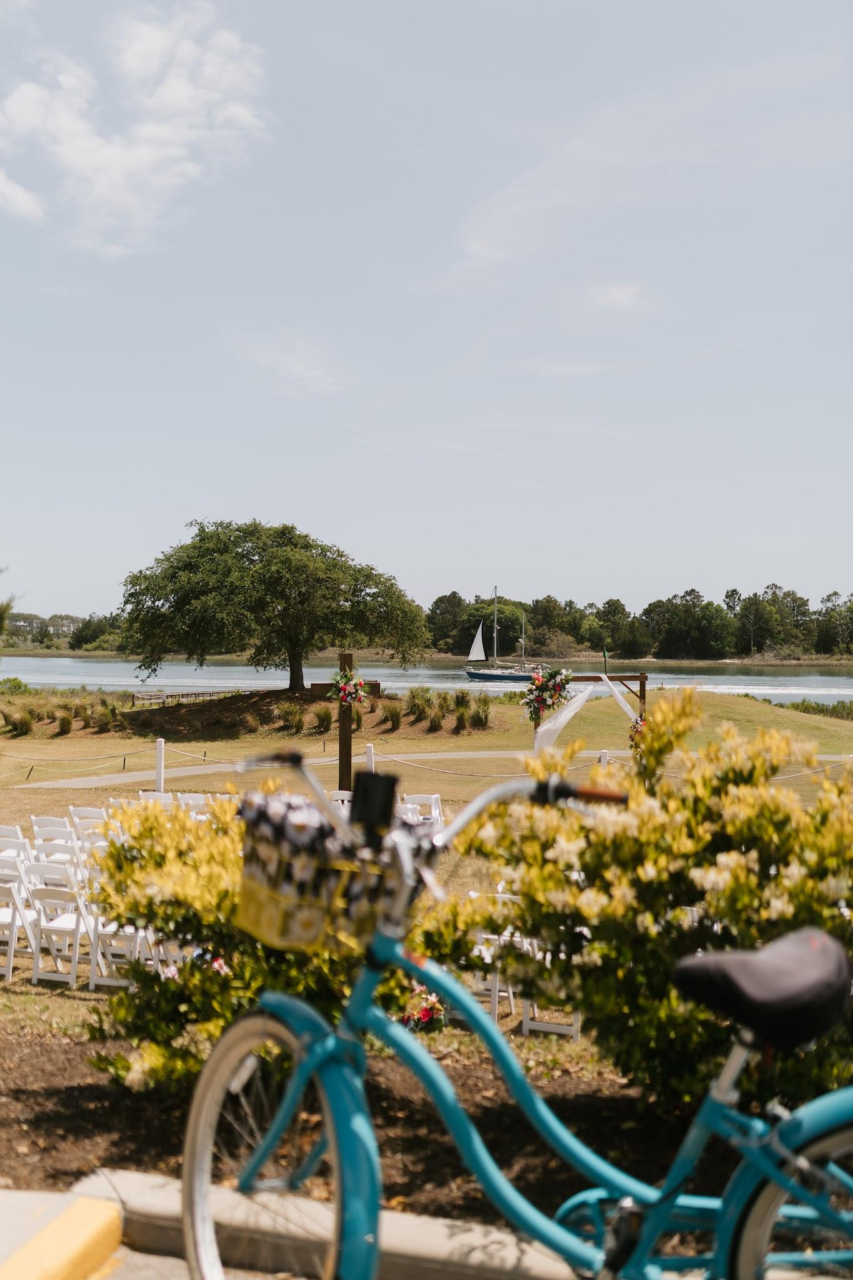
The waterfront wedding ceremony site framed through a blue beach cruiser that was parked on the property.
The Links at Brick Landing - Ocean Isle Beach, NC

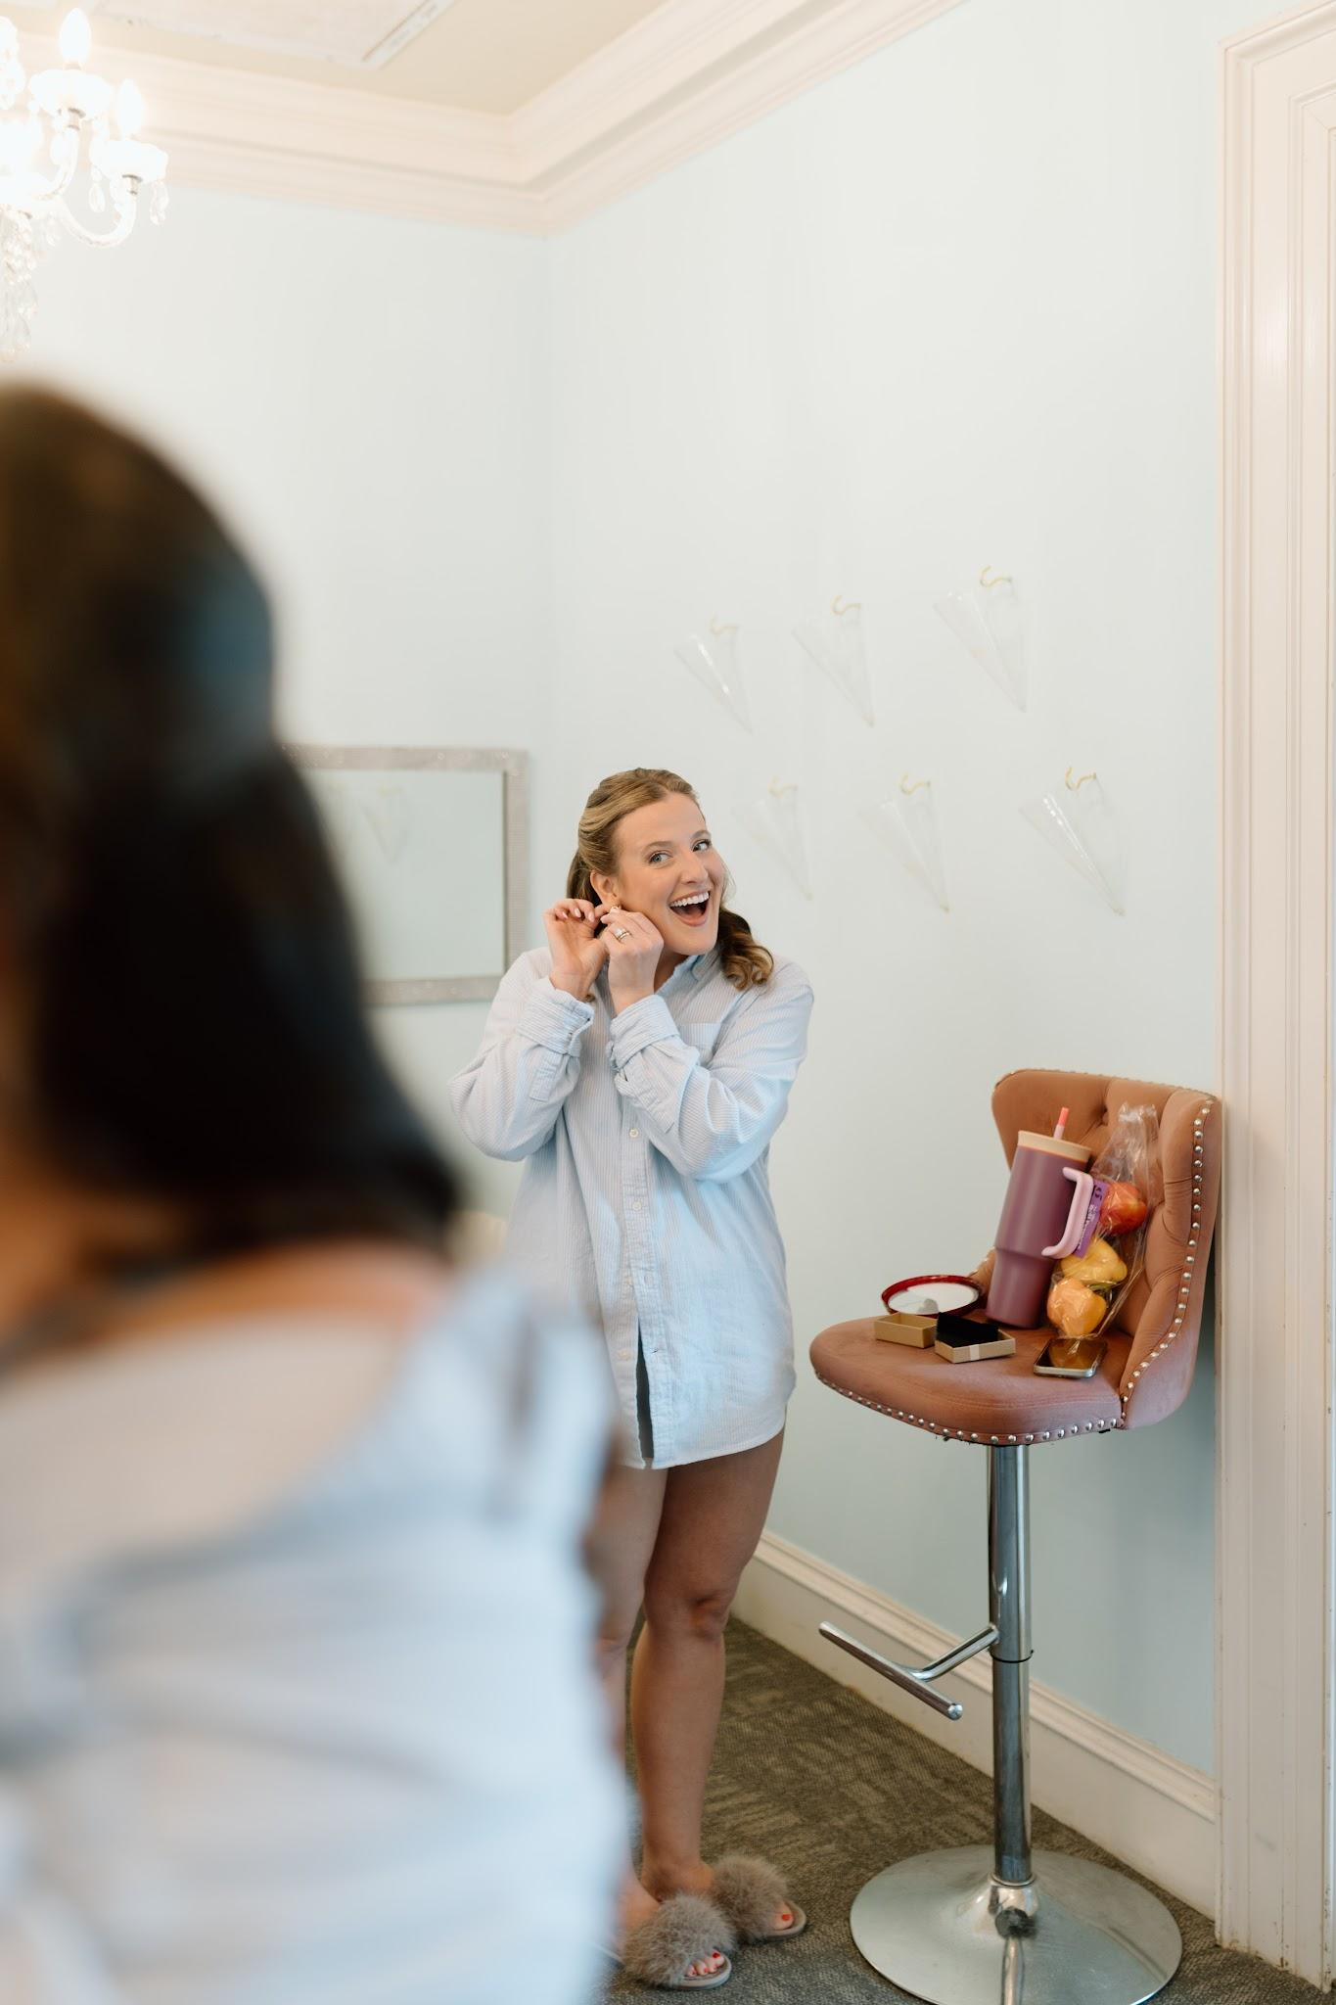
Smiles in excitement for the surprise earrings Tori gifted to all of her bridesmaids before the ceremony.
Dunes West Golf and River Club - Mt. Pleasant, SC

